JOBSHEET
Case Study 2

- Purpose
- Students are able to solve case study problems by applying the concept of Linear Data Structure
- Students are able to apply sorting and searching algorithms according to case studies
- Practical Work
Processing Time : 200 minutes

Work Instructions:
Each student creates a program code based on the case studies that have been given. Make sure the program is running properly, implementing all requested features, and dynamic (using the menu to select features).
Case Study Questions:
At lunchtime, the Royal Delish restaurant has many customers coming at the same time.
Cashier has difficulty recording the queue of buyers and food orders because the process is still done manually.
As a result:
- Queue numbers are often confused.
- Buyer data is not neatly recorded.
- Food orders are difficult to recap.
- The calculation of total revenue often goes wrong.
To overcome this problem, a queue information system based on Linked List/Double Linked List was created.
System flow:
- The buyer comes and takes the queue number.
- The buyer's data is entered into the system.
- When called, the buyer places a food order.
- Order data is stored.
- The system can display order reports and total restaurant revenue.

In this system there are two main classes, namely:
Buyer
name : String
phoneNumber : String
Buyer(String b, String c)
Order
orderCode: int
orderName: String
price : Int
Order(int a, String b, int d)

The image above is an example of a class diagram of the Buyer and Order. Attributes and methods can be added more than in the diagram.

Features That Must Be Available :
- Adding a Queue
When selecting the add queue menu, the system will add the queue number according to the order of the existing queue. Queue numbers can be created automatically. Then the system will ask for input in the form of the buyer's name, and cellphone number. The data that has been entered will be stored in the linked list.
Example:
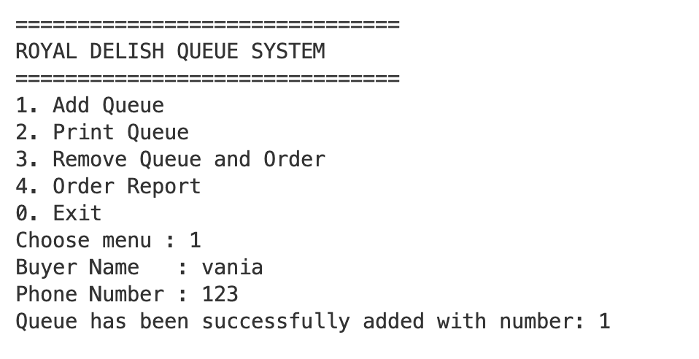
Note: please use adding data through object creation using a constructor to avoid time-consuming keyboard data input.
- Print Queue
This menu will display all the queues on the linked list
Example :
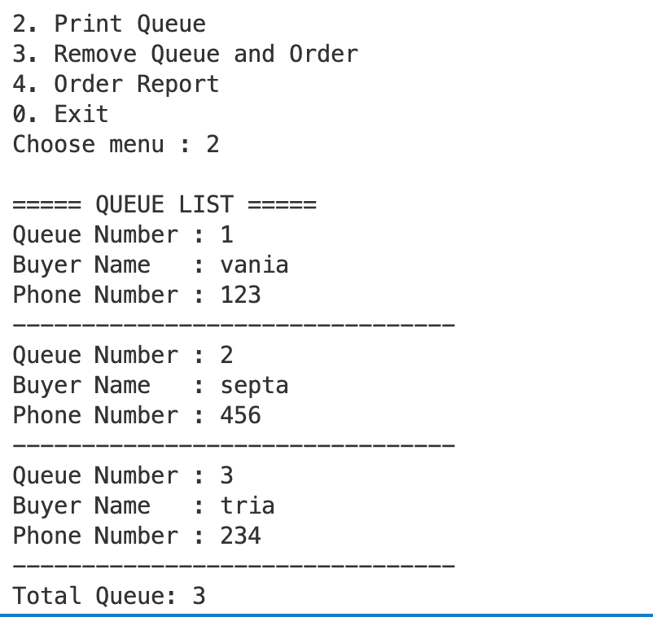

- Delete the Queue
This menu processes the next buyer in the queue. After the buyer is served, the system records the buyer’s order and removes the buyer from the queue.
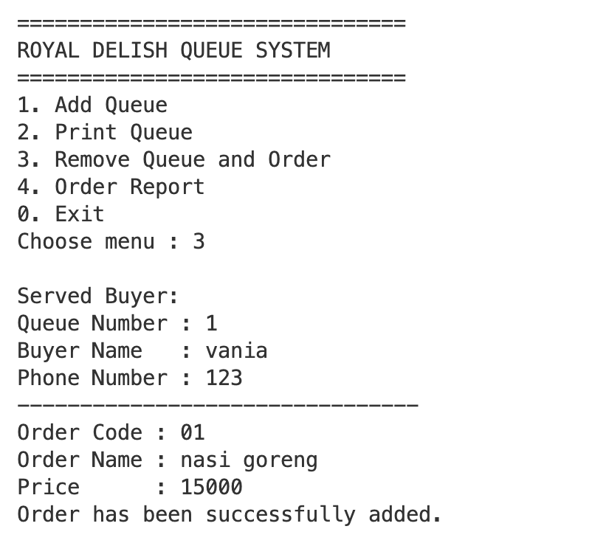

Then the queue should be reduced. The example below has 2 buyers who have ordered food so that the queue is left 2

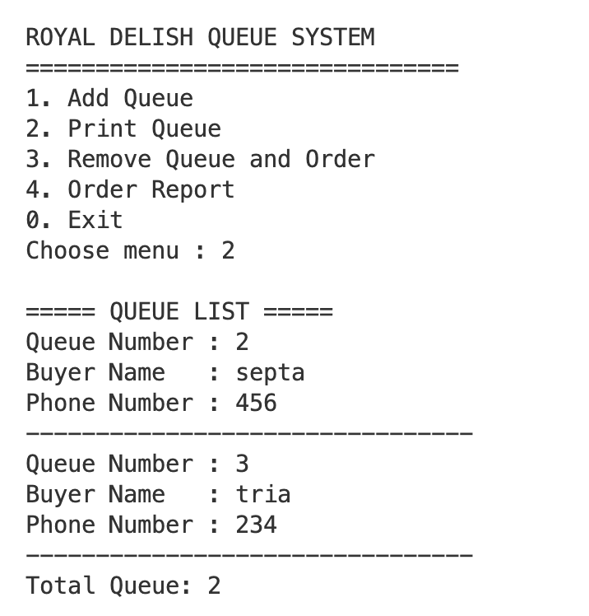

- Order report
This menu is used to display all orders that have been entered. The order data should be displayed in order by order name.

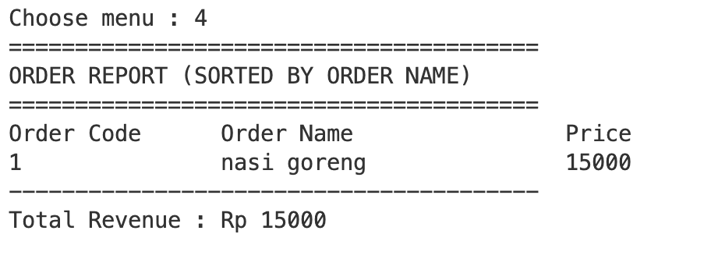

Assessment Rubric
Component : Code Assessment : 30% + CM Practical Test Assessment : 70%
Code Assessment Rubric
Yes | Assessment Aspects | Weight | Score 1 | Score 2 | Score 3
1 | Queue Data Structure Implementation | 20% | Not using linked lists | Using Single Linked List | Using Double Linked Lists Correctly
2 | Implementation of Order Data Structure | 20% | Not using linked lists | Using Single Linked List | Using Double Linked Lists Correctly
3 | Added features | 10% | Not running | Partial Run | Runs well
4 | Queue Print Features | 10% | Not performing | View partial data | Display all data correctly
5 | Feature Delete Queue & Order Input | 15% | Not running | Partial Run | Running according to the problem
6 | Order & Sorting Report | 10% | No sorting | Improper sorting | Sorting works right
7 | Calculate Total Revenue | 10% | Unable to count | Less accurate results | Correct results
8 | Neatness and Naming of Variables | 5% | Untidy | Pretty neat | Neat and easy to understand

Additional Terms
Programs cannot use Collection Frameworks such as:
- ArrayList
- LinkedList
- Tail
- Stack
- Collections.sort()
- Sorting is done manually.
Programs must use objects and constructors.
The use of Double Linked List in both data structures will obtain maximum value in the aspect of data structure.

